 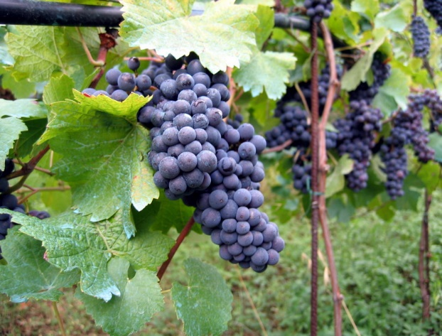

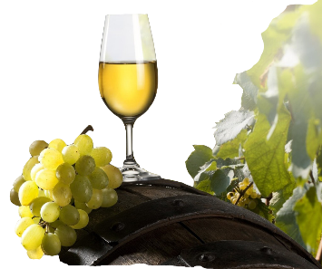

[This Photo](https://pngimg.com/download/9460) by Unknown Author is licensed under [CC BY-NC](https://creativecommons.org/licenses/by-nc/3.0/)

**Wine Tasting Party**

Who: You! Friends, Family, Neighbors

When: June 5, 2021 at 2:00 p.m.

Where: Sturgis Masonic Center

3747 Old Whitewood Road

Sturgis, SD

What: Wine tasting fundraiser

Why: 10% of the purchase price of the wine goes to Daughters of the Nile Foundation – a 501 (c) 3 organization - to support the Shriners’ Hospitals and Clinics.

Cost: $ 5.00 which includes hors d’oeuvres!

**RSVP: Nina 307-214-2730;** [**ninawyo@gmail.com**](mailto:ninawyo@gmail.com)

**Patty 605-786-5802;** [**mapate50@gmail.com**](mailto:mapate50@gmail.com)

(so we have enough wine!)